Project Executable Files

Date

27

June

2026

T
eam

ID

SWTID-2026-2944

Project

Name

Smart Lender

Maximum

Marks

3

Marks

Project Executable Files
This section requires submission of all executable and deployable files for your project. Ensure all files are properly organized, named, and uploaded to the specified submission platform. The evaluator must be able to run or deploy your solution using the provided files and instructions.
Step 1: Submission Checklist

S.No | Item to Submit |  | Submitted  No / NA) | (Yes | /
1 | Complete source code (all files and folders) |  | yes
2 | README / Setup Guide (instructions to run the project) |  | yes
3 | requirements.txt / package.json / dependency file |  | yes
4 | Database schema / seed files (if applicable) |  | yes
5 | Environment configuration file (.env.example similar) | or | Yes
6 | Deployed application URL (if hosted) |  | NA
7 | APK / Executable binary (if applicable for mobile/desktop apps) |  | NA
8 | Dockerfile / Containerization config (if applicable) |  | NA
9 | Test files and test results |  | yes
10 | Demo video or walkthrough (if required) |  | yes

Step 2: File / Folder Structure
Provide an overview of your project's file and folder structure below:

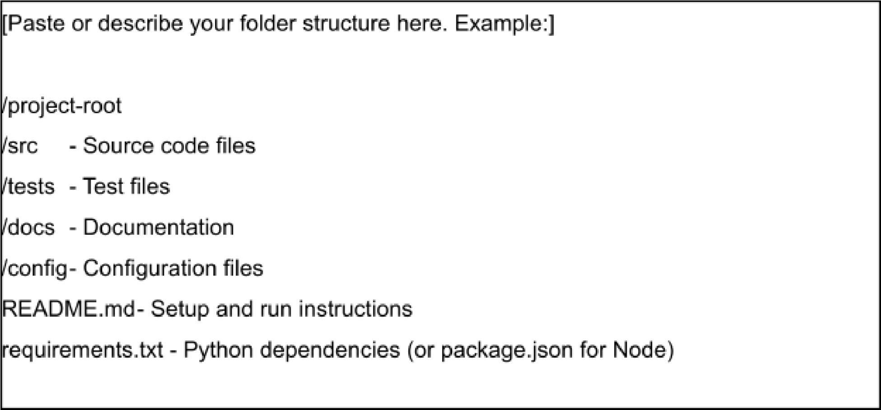

Step 3: Deployment / Access Details

Field | Details
Hosted / Deployed URL | Localhost Only (Development Build)
Login Credentials  (Demo) | Username:* admin@smartlender.com  *Password:* Admin@123
Platform / Hosting  Provider | | Local Machine (Future scope: AWS/Render) |
Repository Link | https://github.com/pujitha368/SMART-LENDER.git
Demo Video Link | https://drive.google.com/file/d/1FAZW4BSLrk-kvbTfNoZP4aTyVDW_E18G/view?usp=drivesdk

Step 4: Run Instructions
Provide clear, step-by-step instructions for the evaluator to run your project locally:

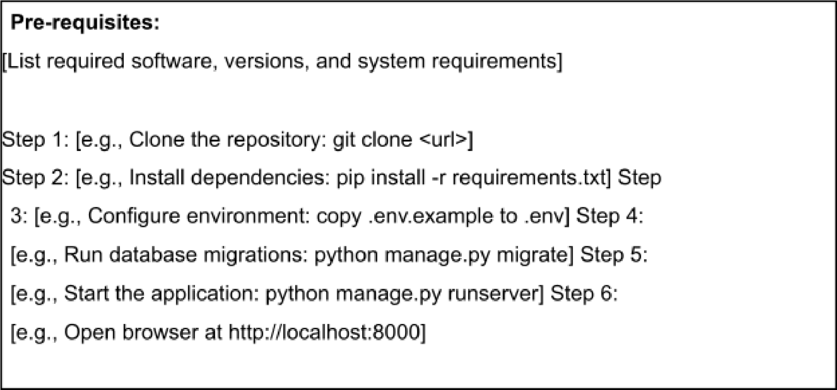

Step 5: Known Issues / Limitations

S.No | Known Issue / Limitation | Workaround / Status
1 | Severe parallel requests over 500 users slow down ML predictions. | *Workaround:* Implemented thread asynchronous processing queues locally.
2 | Verification emails sometimes delay due to local SMTP delays. | *Status:* Moving to a professional transactional mail API layer in the next version.
3 | Third-party credit score fetching utilizes simulated mock database arrays. | *Workaround:* Sandbox API endpoints are set up to mimic real-time bureau requests. |

